# Introduction

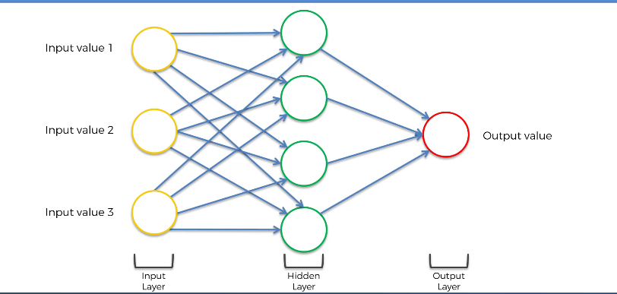

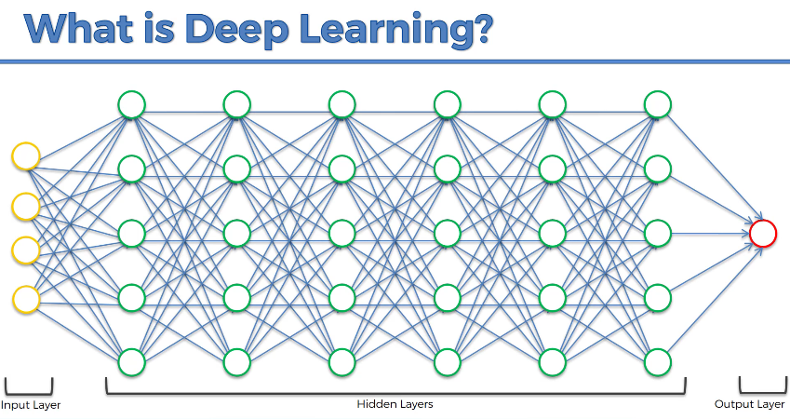

# Codes and Datasets

<https://www.superdatascience.com/deep-learning>

# Plan

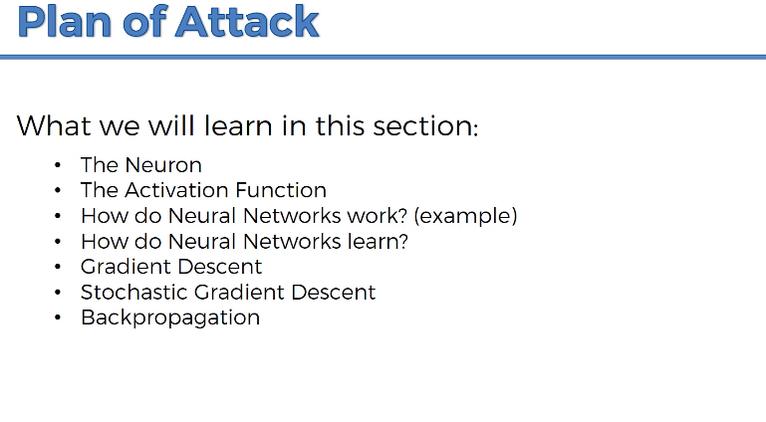

# Neurons

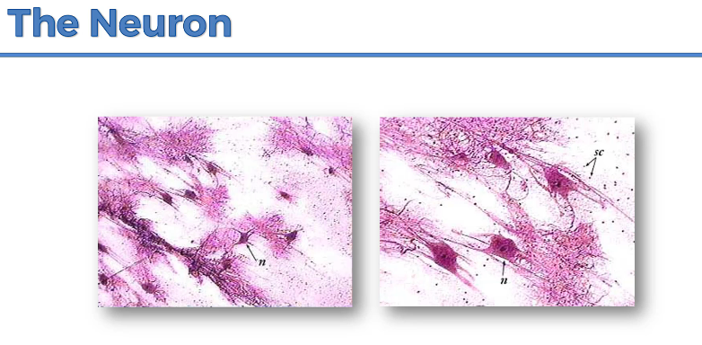

Neurons in human mind.

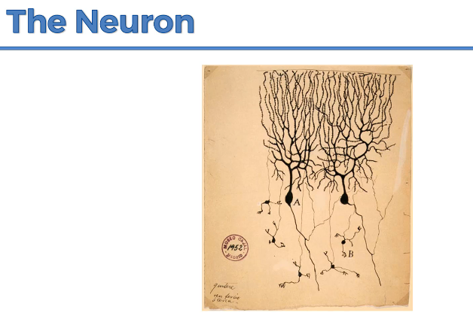

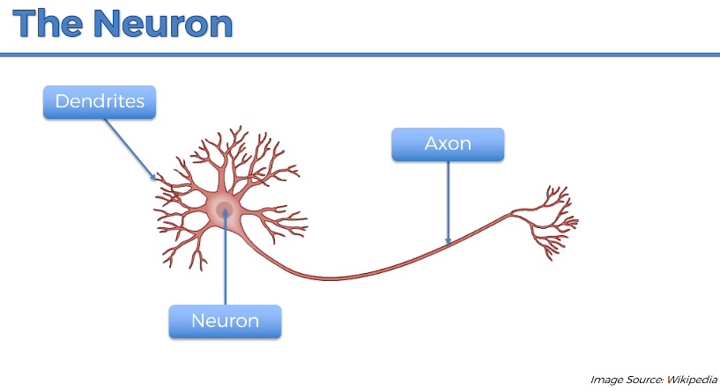

Dendrites – receivers of the signals

Axon – transmitter of the signals

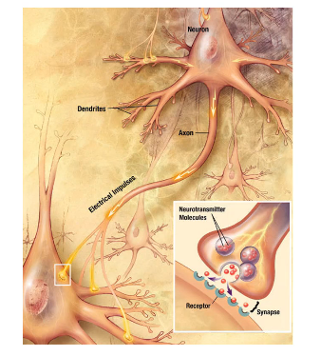

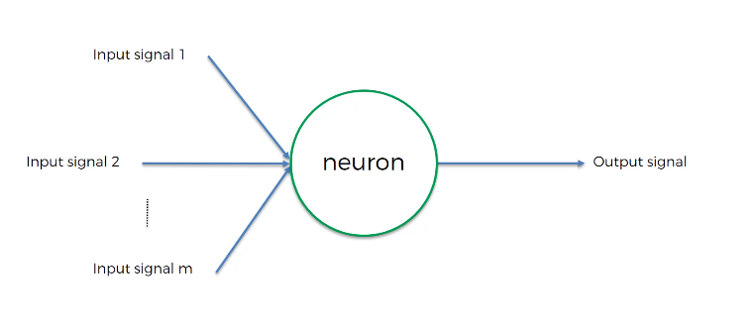

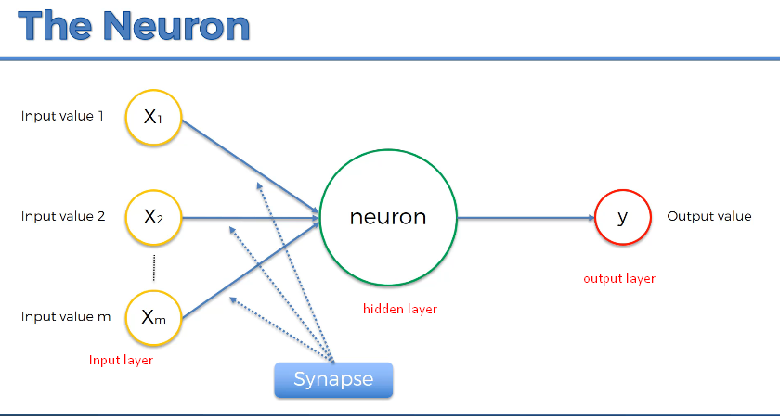

In case of humans, input neurons are like 5 senses.

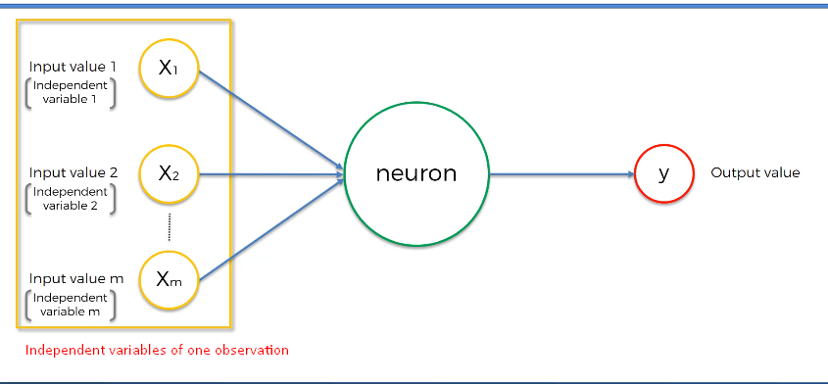

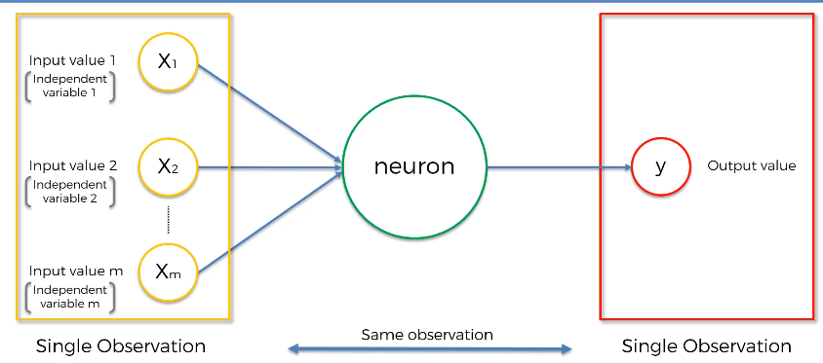

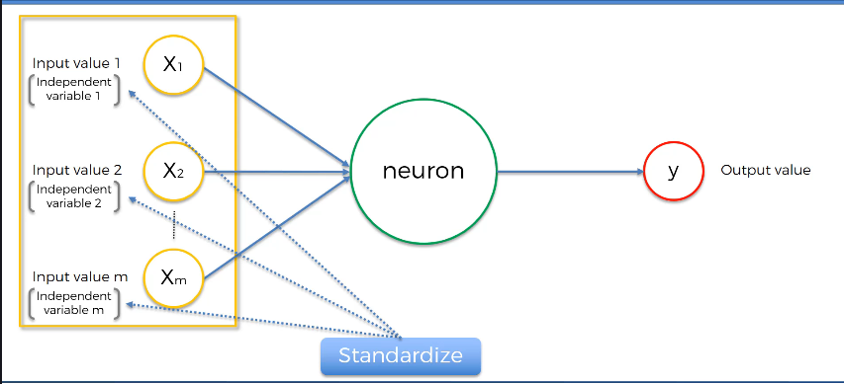

Normalization and Standardization

<https://www.youtube.com/watch?v=bqhQ2LWBheQ&t=84s>

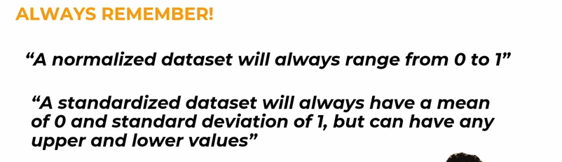

Standardization is also called Z-score Normalization.

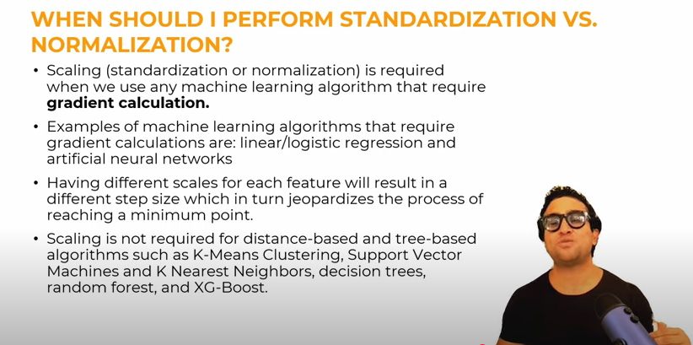

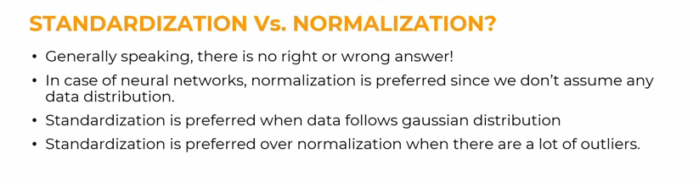

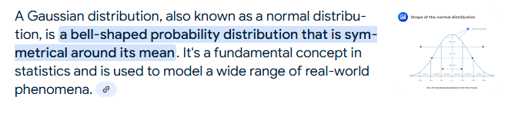

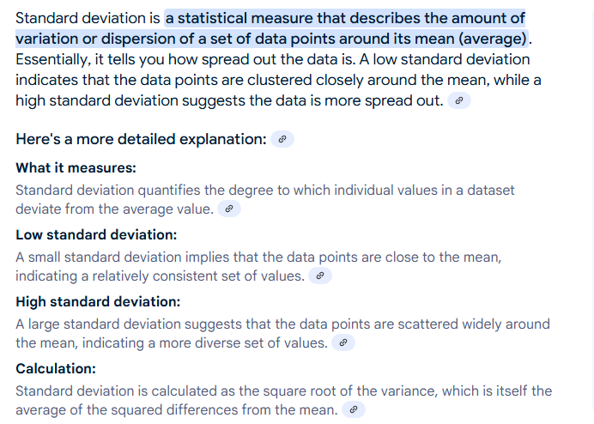

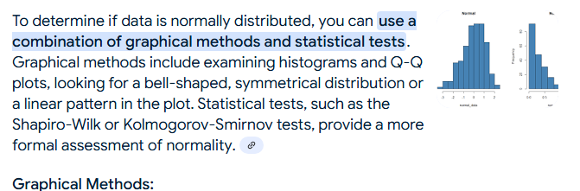

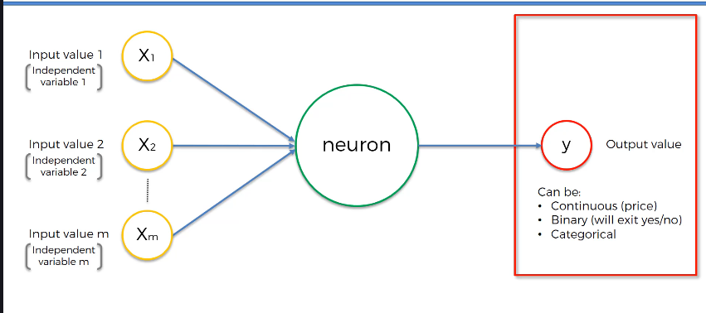

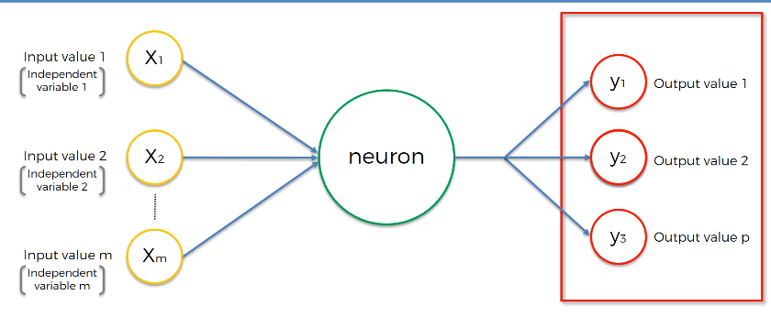

In case of categorical output, you need multiple output neurons (one for each category).

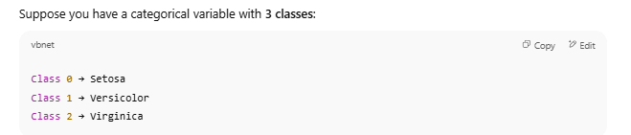

If you only had **1 output neuron**, it couldn’t distinguish among **3+ classes** — it can only give a yes/no signal.

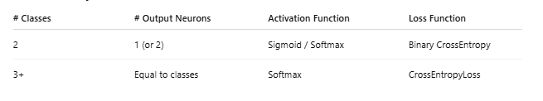

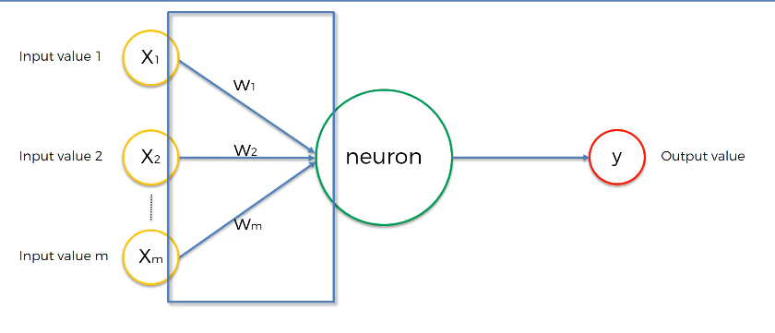

Weights get adjusted during the process of training the Neural Network. That is when Gradient Descent and Back Propagation come into play.

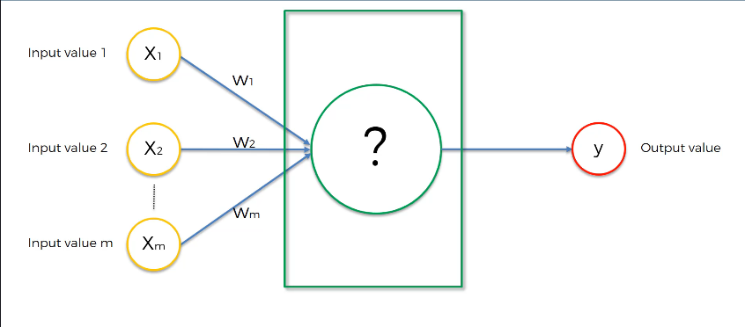

What happens in the neuron?

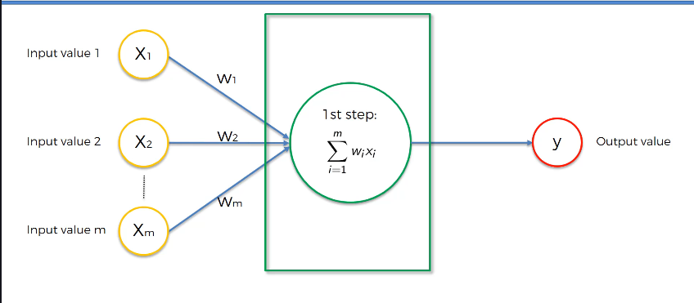

First step is to just do x1w1+x2w2+…..+xmwm

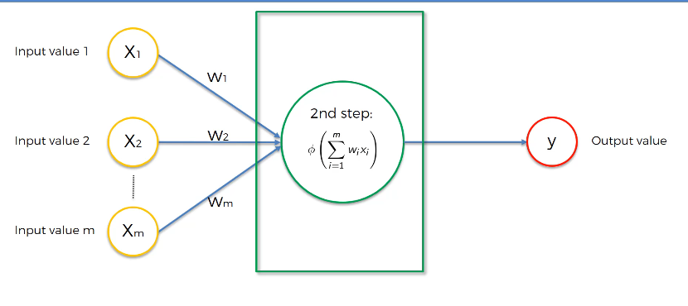

Second step is to apply Activation Function.

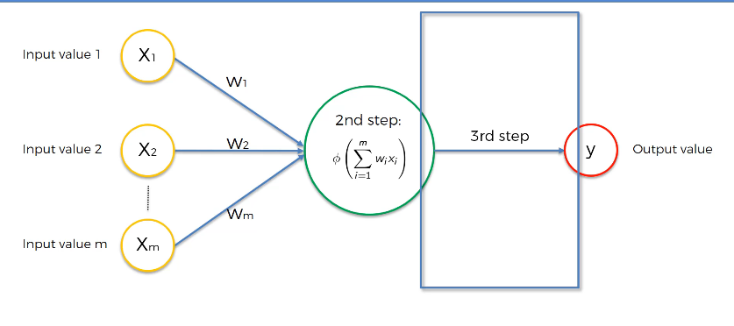

Third step is passing the data to the next neuron down the line.

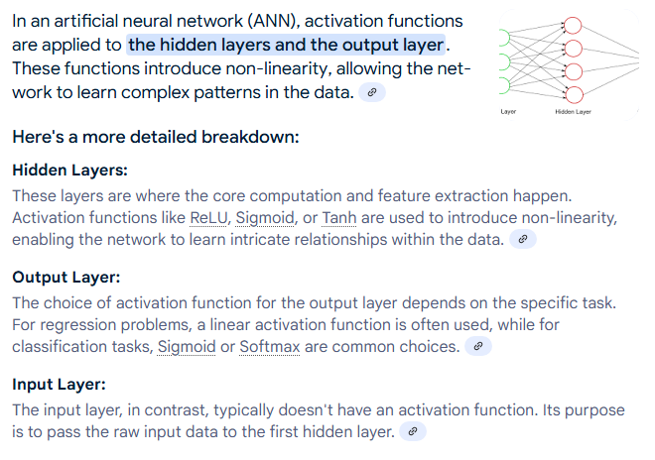

# Activation Function